Texas Commission on Environmental Quality
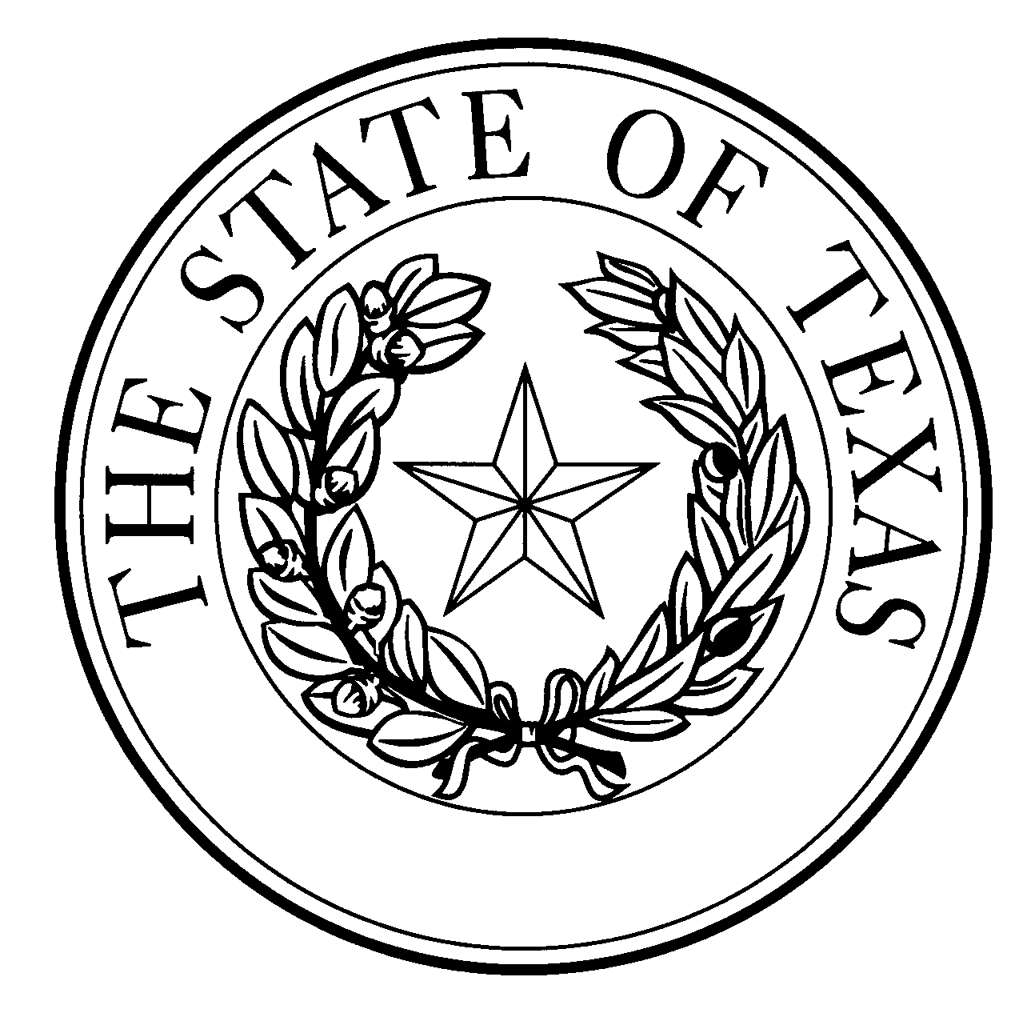
  - Notice of Concentrated Animal Feeding Operation Application
General Permit Authorization No. TXG920840
Application. Ball Land, LLLP, 13401 U.S. Highway 385, Dalhart, Texas, 79022 has applied to the Texas Commission on Environmental Quality (TCEQ) under General Permit No. TXG920000 for a non-substantial change to the terms of the nutrient management plan (NMP) previously submitted to the TCEQ. The Applicant is proposing to remove proposed Retention Control Structure (RCS) #10 and revise the facility design calculations for proposed RCSs #6 - #9 due to the proposed pen and pond expansion and due to the decrease of manure production from the headcount reallocation. The facility maps were updated to reflect the proposed changes. The currently authorized maximum capacity of 188,000 head, of which none are milking cows, the total land application area of 1,332 acres, the list of alternative crops and yield goals, and the RCS design calculations for RCSs #1 - #5 will not change. The notice of change application and the updated NMP were received by TCEQ on August 16, 2023.
No discharge of pollutants into the waters in the state is authorized by this general permit except under chronic or catastrophic rainfall conditions or events. All waste and wastewater will be beneficially used on agricultural land.
The facility is located at 13401 U.S. Highway 385, Dalhart, Dallam County, Texas. The facility is located in the drainage area of the Canadian River in Segment No. 0100 of the Canadian River Basin. The following link to an electronic map of the site or facility’s general location is provided as a public courtesy and is not part of the application or notice. https://gisweb.tceq.texas.gov/LocationMapper/?marker=-102.54111,36.233333&level=18. For the exact location, refer to the application.
The Executive Director of the TCEQ has approved the proposed non-substantial change to the terms of the NMP. The revised terms of the NMP have been included in the permit record and it is available at the TCEQ’s Central Records, 12100 Park 35 Circle Austin, Texas 78753.
Information. For additional information about this application, contact Kayla Robichaux at (512) 239-4742. Si desea información en Español, puede llamar al 1-800-687-4040. General information regarding the TCEQ can be found at our web site at www.tceq.texas.gov/.

Issued: October 19, 2023

